**BLOOD BANK MANAGEMENT SYSTEM**

**A MINOR PROJECT REPORT**

SUBMITTED IN PARTIAL FULFILLMENT OF THE REQUIREMENTS FOR THE AWARD OF

THE DEGREE OF

|  |  |
| --- | --- |
|  | **BACHELOR OF COMPUTER APPLICATION** |
|  | (Computer Science & Engineering / Computer Application) |
|  | **SUBMITTED TO** |
|  | **ITM UNIVERSITY GWALIOR** |
|  | **SUBMITTED BY** |
| **Name of Student(s)** | **University Roll No.** |
| Aditya Mukul | BETN1CS15007 |
| Anuj Kumar Singh | BETN1CS15021 |
| Jateen Sharda | BETN1CS15046 |
|  | **GUIDED BY** |
|  | MR AMIT SINGH CHAUHAN |
|  | ASST. PROFESSOR |
|  | April 2018 |
|  |  |



**ITM UNIVERSITY AH-43, Bypass Turari, Jhansi Road, Gwalior (M.P)**

**ACKNOWLEDGEMENT**

I would like to place on record my deep sense of gratitude to Professor Mrs. Pallavi Khatri, HOD-Dept. of CSE / ICT, ITM UNIVERSITY Gwalior, Madhya Pradesh, India for her generous guidance, help and useful suggestions.

I express my sincere gratitude to Asst. Professor Amit Singh Chauhan, Dept. of CSE/ICT, ITM UNIVERSITY Gwalior, Madhya Pradesh, India, for his stimulating guidance, continuous encouragement and supervision throughout the course of present work.

I also wish to extend my thanks to Asst. Professor Mradhul Dhakar and other colleagues for attending my seminars and for their insightful comments and constructive suggestions to improve the quality of this project work.

**Signature(s) of Students**

Aditya Mukul (BETN1CS15007)

Anuj Kumar Singh (BETN1CS15021)

Jateen Sharda (BETN1CS15046)

**CERTIFICATE**

I hereby certify that the work which is being presented in the B. Tech Minor Project Report entitled **“BLOOD BANK MANAGEMENT SYSTEM”,** in partial fulfilment of the requirements for the award of the **Bachelor of Technology in Computer Science & Engineering / Computer Applications** and submitted tothe Department of CSE / ICT, ITM UNIVERSITY GWALIOR, Madhya Pradesh, India is an authentic record of my own work under the guidance of **Mr. Amit Singh Chauhan Asst. Professor,** **CSE/CA Department**.

The matter presented in this Project Report has not been submitted by me for the award of any other degree elsewhere.

**Signature of Student (S)**

Aditya Mukul (BETN1CS15007) Anuj K Singh (BETN1CS15021) Jateen Sharda (BETN1CS15046)

This is to certify that the above statement made by the student(s) is correct & best of my knowledge.

**Signature of Guide(s)**

**Date:** **Mr. Amit Singh Chauhan (Asst. Professor)**

**Head of the Department**

**Computer Science & Engineering / Computer Applications**

**TABLE OF CONTENTS**

* **ACKNOWLEDGEMENT**
* **CERTIFICATE FROM THE GUIDE**

**CHAPTER PARTICULARS**

**CHAPTER I**

* **INTRODUCTION**
* **LITERATURE REVIEWS**

**CHAPTER II**

* **SYSTEM ANALYSIS**

**CHAPTER III**

* **CONCLUSION**
* **BIBLIOGRAPHY/ REFERNCES**
* INTRODUCTION:

Blood Bank Management System is a way to maintain all the information about the blood donor, different blood groups available in blood bank and help them to manage in a best way. Blood Bank Management System can help to collect bloods and distribute to needy peoples who require blood.

Key features of Blood Bank Management System -:

* + - * BBMS is capable to manage List of donors as well as their blood groups.
      * BBMS is able to manage all the necessary information about donor like Contact no, previous blood donates summary etc…

` Blood Bank Management System is developed on PHP platform and handled by MySQL database to store blood donor specific information.

* LITERATURE REVIEW

Today the business and services environment is very competitive and complex. Even if modern technology and highly qualified and well-trained staff are available, without an efficient information management system, organizations cannot function effectively. The development of a Blood Bank Management System, which is developed using quality and effective computer systems applications for providing modern information management services in the medical and health care sector [1].

Some online systems are used in some foreign countries. The main goal of the Blood Bank Management system is to gather all the blood donors into one place automatically and inform them constantly about the opportunities to donate blood via a SMS to the donor’s mobile phone. Ultimately, the system provides proper communication among the blood donors, campaign organizers and the people who need blood [2].

“A Study on Blood Bank Management System” by A. Clemen Teena, K. Sankar and S. Kannan is an information management system which helps to manage the records of donors and patients at a blood bank. The system will allow the authorized blood bank officer to login using a secret password and easily manage the records of the blood donors and the patients in need of blood [3].

A computerized Blood Bank Management system is described. Features include product oriented data input, inventory control reports, product utilization reports, rapid retrieval of individual patient reports. Relative benefits of the system are discussed [4].

* Blood bank management system under progress:

Indian Blood Bank Society is a noble charity organization formed with the active initiation and guidance of Lt. Col. (Hon.) Dr. Mohanlal, under Act For Humanity. Act For Humanity is a Non-profit organization founded by Mr. Esahaque Eswaramangalam and a group of young social workers during 2004, with Lt. Col. (Hon.) Dr. Mohanlal as its goodwill ambassador, aiming to fight against terrorism and fanatic activities. Act For Humanity aims to enhance the humanistic elements of each individual and prepare them to be tolerant, responsive, accountable and responsible social citizen.

Indian Blood Bank is aimed at promoting the awareness of blood donation among the public. It is committed to stay ahead of all linguistic-rational-religious-political differences and shall be fully focusing its objectives in health care activities, with technology support from WebCastle Media Pvt. Ltd., Cochin.

* Indian Red Cross Society:

The Indian Red Cross is a voluntary humanitarian organization having a network of over 700 branches throughout the country, providing relief in times of disasters/emergencies and promotes health & care of the vulnerable people and communities. It is a leading member of the largest independent humanitarian organization in the world, the International Red Cross & Red Crescent Movement. The Mission of the Indian Red Cross is to inspire, encourage and initiate at all times all forms of humanitarian activities so that human suffering can be minimized and even prevented and thus contribute to creating more congenial climate for peace.

**Origin of Indian Red Cross Society**

During the first world war in 1914, India had no organization for relief services to the affected soldiers, except a branch of the St. John Ambulance Association and by a Joint Committee of the British Red Cross. Later, a branch of the same Committee was started to undertake the much needed relief services in collaboration with the St. John Ambulance Association in aid of the soldiers as well as civilian sufferers of the horrors of that great war. A bill to constitute the Indian Red Cross Society, Independent of the British Red Cross, was introduced in the Indian Legislative Council on 3rd March 1920 by Sir Claude Hill, member of the Viceroy's Executive Council who was also Chairman of the Joint war Committee in India . The Bill was passed on 17th March 1920 and became Act XV of 1920 with the assent of the Governor General on the 20th March 1920.

Chapter II

* HARDWARE SPECIFICATION

|  |  |
| --- | --- |
| PROCESSOR | 3.5GHz |
| RAM | 1 GB |
| HARDDISK | 160 GB |

* SOFTWARE SPECIFICATION

|  |  |
| --- | --- |
| OPERATING SYSTEM | WINDOWS 10 |
| RUN TIME ENVIRONMENT | XAMPP |
| WEB SERVER | XAMPP |
| FRONT END | PHP, HTML |
| BACK END | SQL |
| WEB BROWSER | INTERNET EXPLORER 6.0 AND ABOVE |

* FEASIBILTY
* Operation feasibility

This is mainly related to human organizational and political aspects. The points to be considered are:

• What changes will be brought with the system?  
• What organizational structure are disturbed?  
• What new skills will be required?

* Technical feasibility

This is concerned with specifying equipment and softwares that will successfully satisfy that user requirements. The technical needs of system may vary considerably, but might include :

• The facility to produce outputs in a given time.  
• Response time under certain conditions.  
• Ability to process a certain volume of transaction at a particular speed.  
• Facility to communicate data to distant locations.

* Economical feasibility

Economic analysis is more frequent used technique for evaluating the effectiveness of a proposed system. More commonly known as cost/benefits analysis, the procedure is to determine the benefits and savings that are expected from a proposed system and compare them with cost.

* As in the operational feasibility it seems that whenever a user needs a blood unit it can contact the hospitals and get the information of donor.
* As in the technical feasibility it seems that the requirement of the general softwares such as XAMPP, WEB BROWSER which are easily available, reliable and easy to operate.
* As in the economical feasibility it seems that it is very cheap and least maintainance required.

**On the basis of above feasibility parameters that the given project is practically feasible.**

* Data Flow Chart

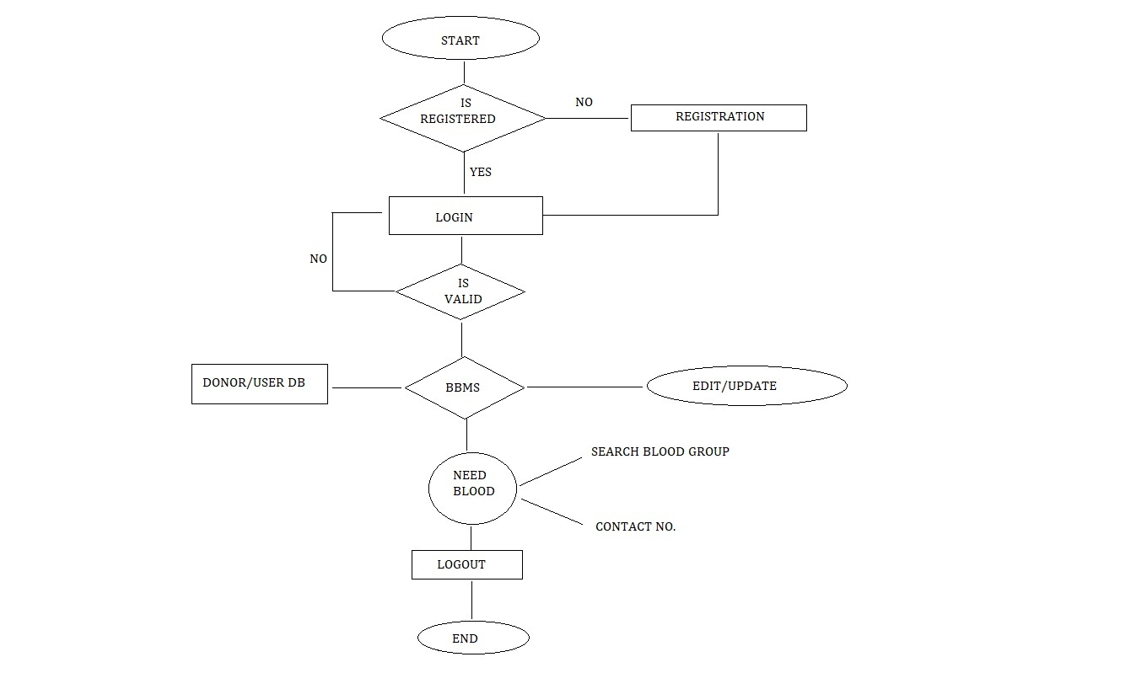

* Entity Relation Diagram

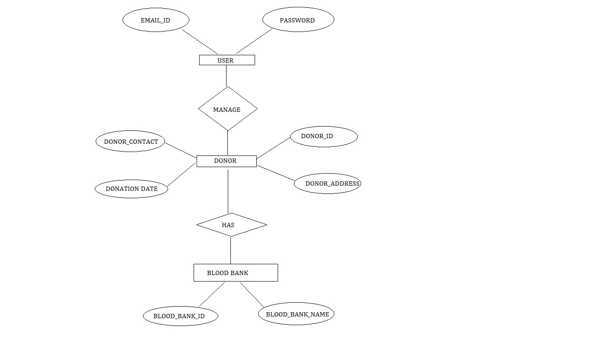

* TESTING
* White Box Testing

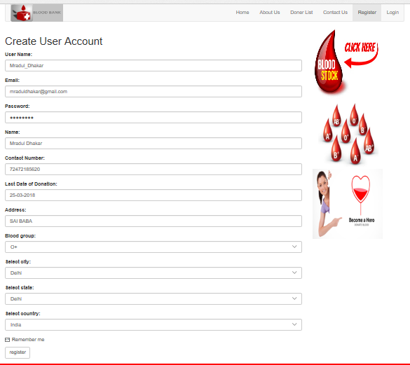

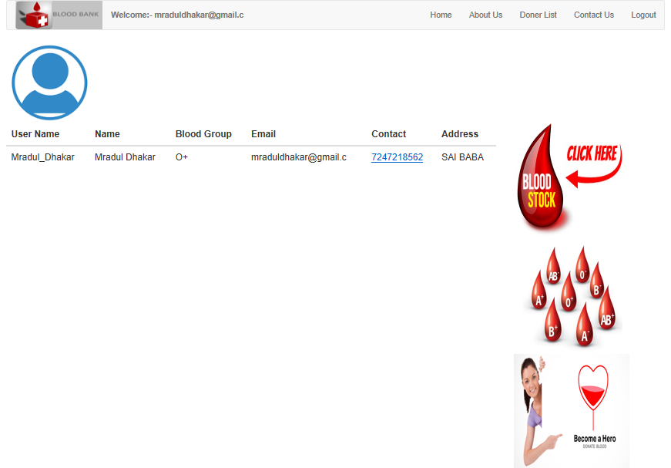

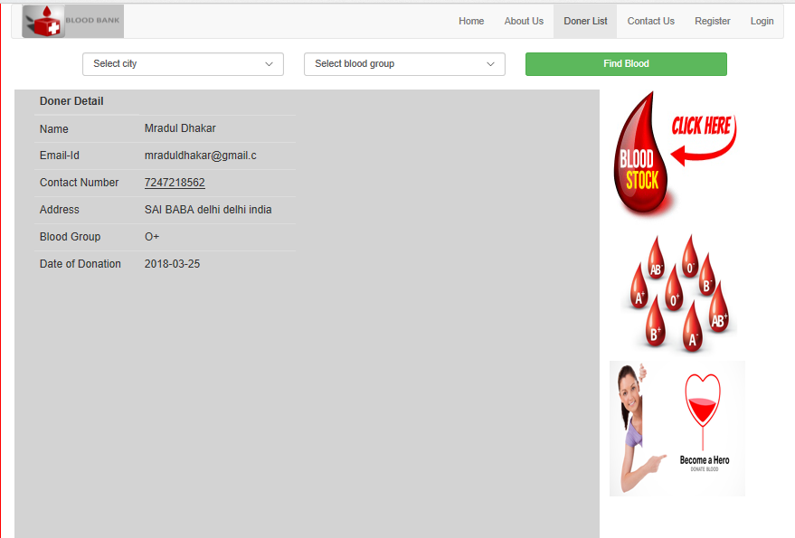

TEST CASES:

1. If User Already exist,

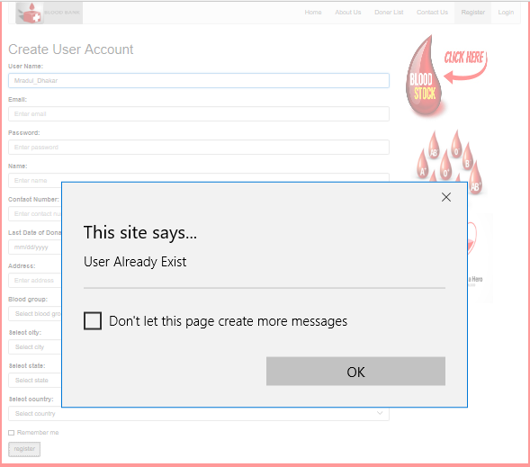

1. If user does not exist,

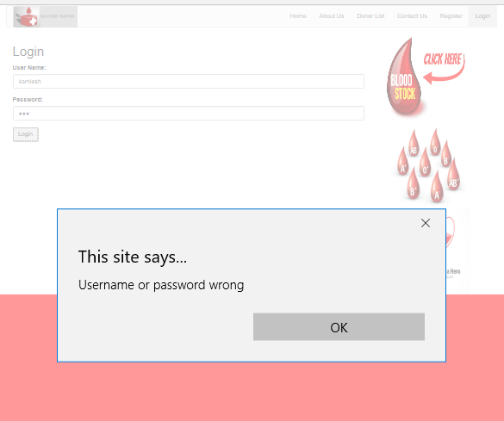

1. If Donor information is empty,

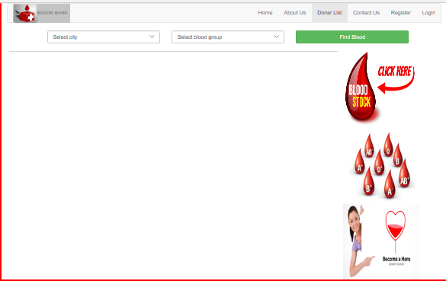

1. If email ID does not contain @,

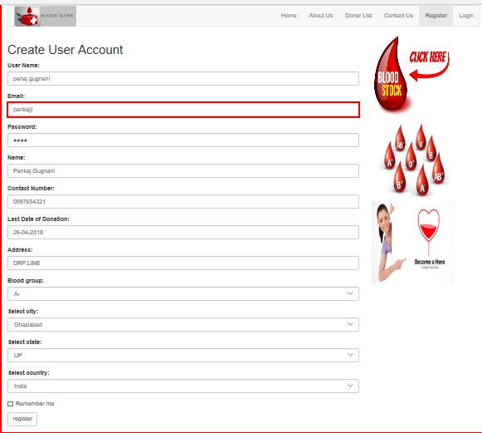

|  |  |  |  |
| --- | --- | --- | --- |
| Test Cases | Expected outcome | Actual outcome | Check list |
| if user does not exist | Login fail | Login fail |  |
| If email id does not contain @ | User created | Enter a valid email address | X |
| If user already exist | New user created | User already exist | X |
| If donor information empty | Donor list visible | No action performed | X |

**CHAPTER – III**

* CONCLUSION & RESULT:

This Report represents the Blood Management System features and functionalities. Proper monitoring & management of blood can save a life of needy person who require blood as earlier.

There are some problems and difficulty in this system which we overcome by using modern techniques.

* BIBLIOGRAPHY/REFERENCES:

1. <https://www.researchgate.net/publication/307585563_Management_of_Blood_Donation_System_Literature_Review_and_Research_Perspectives>.
2. <http://www.ijrter.com/papers/volume-3/issue-1/blood-bank-management-system.pdf>
3. “A Study on Blood Bank Management System” by A. Clemen Teena, K. Sankar and S. Kannan, Department of MCA, Bharath University, Selaiyur, Chennai 73, Tamil Nadu, India
4. <http://www.tngovbloodbank.in/>